Practical 14

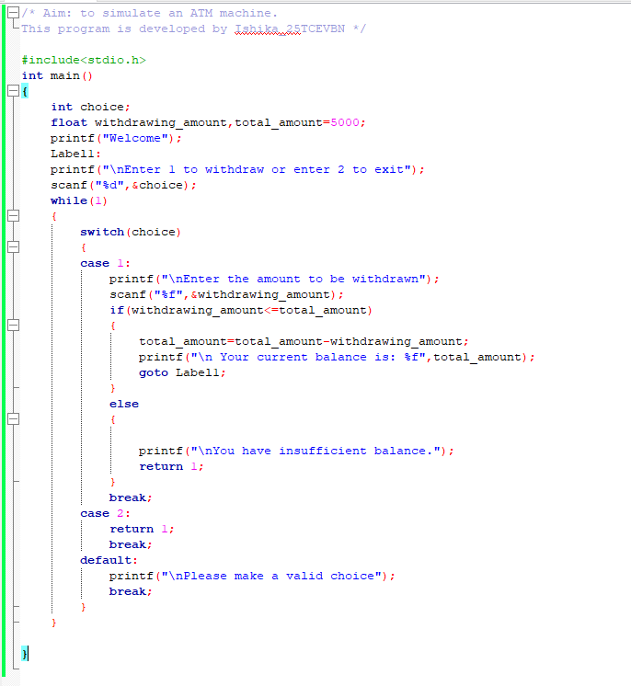

Case 1: There is sufficient balance

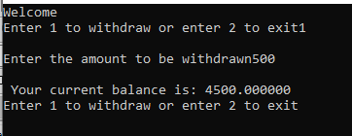

Case 2: There is insufficient balance

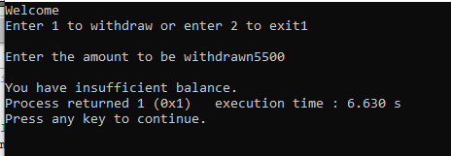

When user makes an invalid choice

